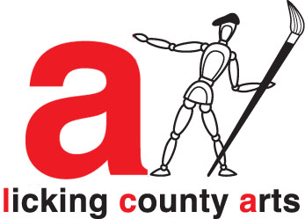
LICKING COUNTY ARTS INTAKE FORM

Name: __________________________________________ Email: ________________________________

Phone numbers: _____________________________________ Show entry fee: $15 (docents, note here when payment was processed) __________

Check one box. Item for: Show (up to 3 items) Gallery Midland Theater case Offsite artwork on location

All wall art must be securely wired for hanging and have title and your name on the back
Artist’s  item # | Item/Title for wall label | Description of item | Medium – if PRINT of an original, note that here | Price

LIABILITY AND PUBLICITY WAIVER:
All pieces of art submitted for shows must be suitable for viewing by children.

Licking County Arts will not be responsible for loss of or damage to your artwork while in our possession. The artist is solely responsible for insurance covering their own artwork. LCA will make every effort to avoid any mishap or loss.

I hereby grant to the Licking County Arts and its assignees, and other successors-in-interest, all rights in any manner or media, including without limitation unrestricted use of artwork and/or other items consigned to the Licking County Arts for purposes of publicity, advertising and sales promotion (including Pinterest and Facebook).

Signature: ______________________________________ Date: _____________________________

updated 6-28-18

